## 9.*Number Convertor

Write a functionthat **converts** a **decimal** **number** to **binary** and **hexadecimal**.

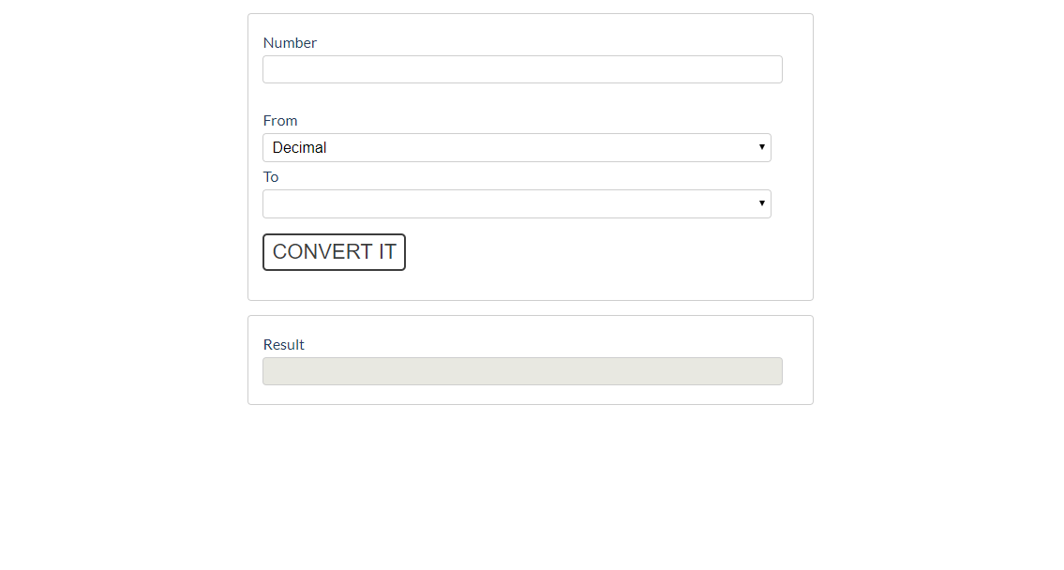

The given number will always be in **decimal format.** The "From" select menu will only have a Decimal option,

but the "To**"** select menu will have **two options**: Binary and **Hexadecimal**.

This means that our program should have the functionality to **convert** **decimal** to **binary** and **decimal** to **hexadecimal**. When you convert to **hexadecimal** it must be **upper case**.

Note that the "To**" select menu** by default is empty. You have to insert the two options (**'Binary'** and **'Hexadecimal'**) inside before continuing. Also, they should have **values** ('**binary**' and '**hexadecimal**').

* When the [Convert it] button is **clicked**, the expected result should appear in the [Result]input field.



 